
MAKERERE UNIVERSITY

COLLEGE OF COMPUTING AND INFORMATICS
SYSTEMS
DEPARTMENT OF NETWORKS.

GROUP7
CONCEPT PAPER

GROUP7 MEMBERS:

NO | NAMES | Reg No | Stud No
1 | Niwandiinda John Martin | 17/U/9138/PS | 217010696
2 | Miiro Henry | 17/U/6112/EVE | 217009093
3 | Onyang Joshua | 17/U/9702/PS | 217016961
4 | Odongo Abraham | 17/ U/9494/PS | 217002258

PREDICTING HOUSE PRICES.

1.0 Introduction
This system will be able to predict the house prices by applying regression model on the acquired dataset.

2.0 Background to the Problem
We are going to use ‘house prices’ dataset obtained from Kaggle (http://www.kaggle.com) to predict the house prices. This dataset constitutes the house prices for King County in United States including Seattle city. It has homes sold between May 2014 and May 2015. It is a structured data as it was got from House Sales in King County, USA.
The dataset has features which include id: a notification of the house, price (in dollars) at which the house was sold, date when the house was sold, number of floors, bedrooms and bathrooms, sizes of living room, lot and base in square feet, location (latitude and longitude), condition of the house, Grade: the overall grade given to the housing unit based on King county grading System and the year when the house was built and renovated.

2.1 Data pipeline
Diagrammatic Overview
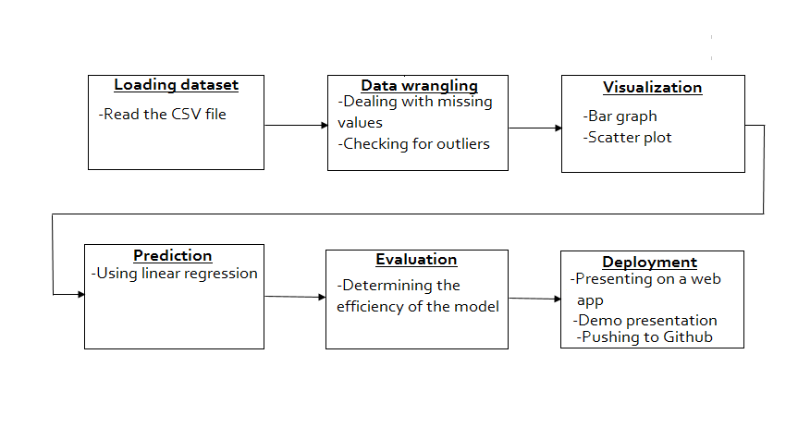
Description of the data pipeline.
- Loading data. This involves reading the csv file.
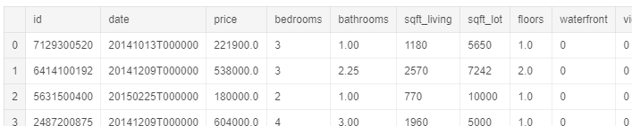
- Data wrangling. We shall check for missing values (using print(df.isnull().sum()) and replace them in case there is any using linear interpolation. We shall also check for the outliers and treat them accordingly if any. This will be by dropping the outlier record, capping the outlier’s data, assigning a new value or transforming them.
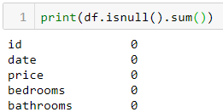
- Building visualization. The dataset is explored by constructing the graphs that is we shall use scatter and bar plots to determine the skewness and correlation of the features. Visualization is the best way to explore and communicate the findings.
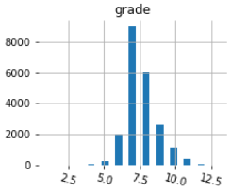
- Getting prediction/Transformation. We shall use linear regression model to get insights and predict future house price trends.
- Evaluation. We shall test for the efficiency and effectiveness of the applied model.
- Deployment and communication. Here we shall demonstrate our system demo to the panel and upload our solution to GitHub.

